YOUSEF ABU ALI

DataBase  Prince Alfred Hospital

User Document

1. User Documentation:
   1. System Overview:

This system is made for the management of the Prince Alfred Hospital in order to enable them to perform some specific tasks on the database. This system contains five tables. The management are able to add a doctor to the database, edit a doctor information in the database, delete a doctor from the database. Moreover, they are able to add a patient to the database, edit patient information in the database, delete a patient from the database. Additionally, they are able to keep track of the number of appointments for each doctor. As well as keeping track of the total number of medical records in the database.

* 1. Using the system:

The username for the managements is (Managements) with the password 111.

After the user inter the username and password they will have the following pages that they can use:

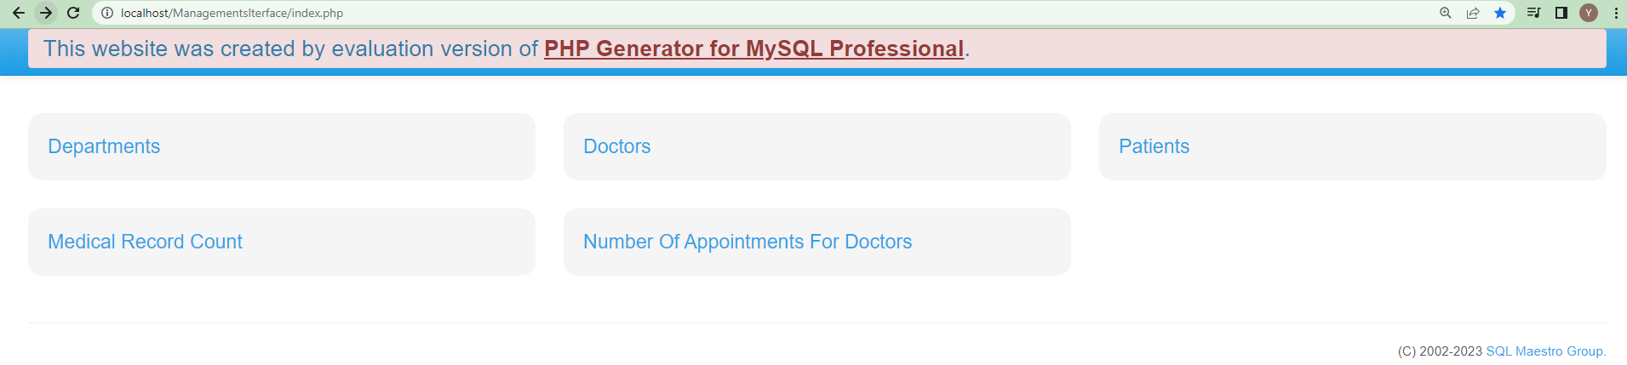

This page contains for tables that the user will be able to access. And in the following step I will explain all the functionalities that the user could do in each table, and how they will able to perform these tasks:

Using the Departments table as an example. Once you click on the Departments table you will have the following page:

The Green arrow shows the name of all the tables available for the user to interact with. The user can simply press on any of the tables names and they will be directed to it.

The Red arrow shows the Name of the current table ( the table we are looking at).

The Blue arrow shows the functionalities that could be done by the user. And they explained in the following illustration:

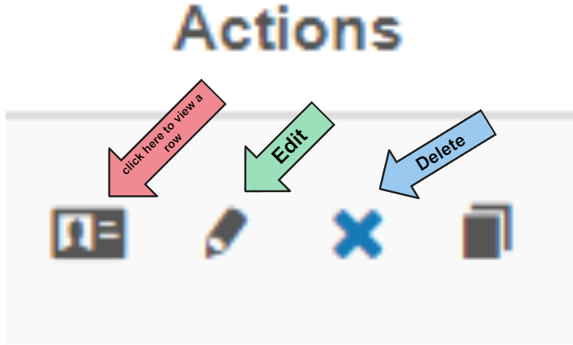

The red arrow shows the view button, this button allows the user to view the information for a specific row.

The green arrow represents the edit button, which allows the user to change any information on a specific row.

The Blue button allows the user to delete a specific row from the data base.

If the user wants to insert a new row on the table:

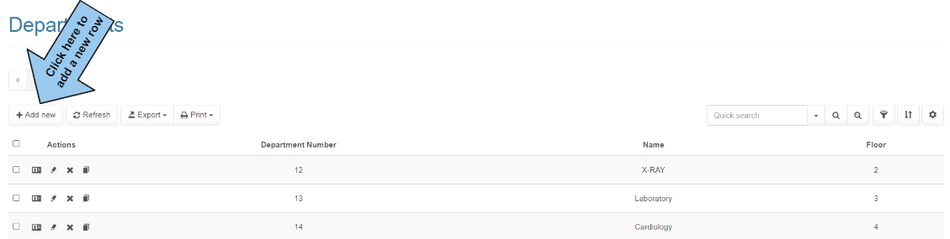

Another thing the user can do is to filter the rows based on a certain information if needed.

You can insert the information you need in the (Quick search) box, and then press on the search button:

Now this all was the normal functionalities that are available for the user on the Departments, Doctors, and Patient tables overall. Let’s get more into each table individually:

Starting with the Departments table:

This table will provide information on the departments available in the Hospital. These departments are used by the patients (visitors of the Hospital clinics) when or if the doctor asked them to visit a certain department after the appointment was finished, in order to perform some tests.

Let’s start with viewing a certain row in the Department table:

Once you click on the view button on any of the rows in the department table you will be taken to a page that represents the information on the row. for example, I will view the first row in the table:



This is what you will get:

If you click on the edit button for that row you will be directed to the following page:

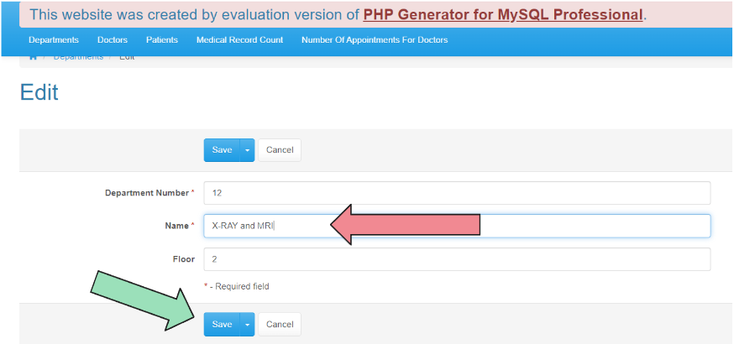

You will have the information of that row written in each field, and you are able to change the information in any of these fields. Once you are done, all you have to do is press on the save button. Any field that you change in that page will affect the row that you have chosen:



Although, you have to make sure not to write a department number that already exists, and not to write a department name that already exists, or you will have an error message like this:

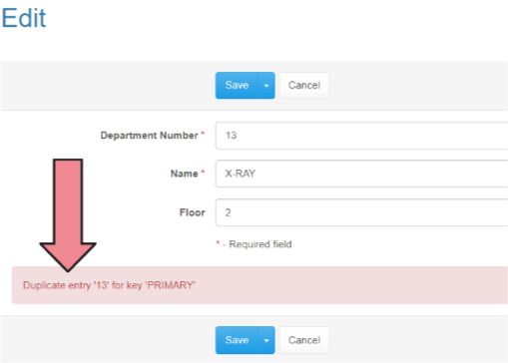

If you wanted to delete a row all you need to do is to press on the delete button and it will be erased.

If you want to add a new row for the database, all you have to do is press on the (Add new) button, and you will be directed to the following page:

All you have to do is to insert the appropriate information in each field. A number for the department number, words for the name of the department, and numbers for the Floor field, which represent in what floor a certain department is. the following is an illustration for this:

And this is the new added row:

All of the previous functionalities could be performed on the Departments, Doctors, and Patients tables. However, there are some rules that I am going to mention when inserting new information in the Doctors and Patients table:

I will start with the insertion for Doctors table:

This table contains four columns that represents the doctor’s information. The doctor id (which can’t be empty and should be a number from 10 digits maximum, and better not to be less than 4 digits ). The Doctor name, the Specialty, and the email address have no specific rules, but they should be clear and correct.

Moving on to inserting a row in the patient’s table:

The patient table contains six columns that represent the patient’s information. The patient ID is the unique number for the patient and should not be similar to any other patient’s id, and it should not be left empty. The First Name field should contain the first name for the patient, and it should not be left empty. The last name shows the patient’s last name. The Birthdate shows the patient’s date of birth. The address contains the address of the patient. The phone number contains the phone number for the patient (10 digits only). Although these four columns don’t have a specific rule, it is better not to leave them empty.

The user can use the button next to the Address field to insert the full Birth date:

Now the last two tables are only used for viewing information in it, and the user can’t perform any operations in it:

The Number of Appointments For Doctors, is a table that shows the number of appointment each doctor has had in their working years in the hospital. This page looks like this:

The only thing the user can do is to perform the quick search operation that I specified earlier.

The Medical Record Count table, is a table that shows the total number of medical records the database contains:

Here we have only 9 medical records total.

To go back to the home page all you have to do is to click on the home shaped button in the left corner of the page:

And you are back to the home page:

* 1. Frequently asked questions:

1. How can I log into the system, what is the username and password that I could use to access the system?

* You can log into the system using the following URL (<http://localhost/ManagementsIterface/medical_record_count.php>)
* The username is: Managements and the password is: 111

1. What are the available tables for me to access in the system?

* You able to use the following tables:
* Departments table
* Doctors table
* Patients table

1. Can I search for a specific row in the table using any of the information for that row?

* Yes, you can insert in the quick access field any information related to that row and it will filter the table accordingly.

1. Is there a Way to Export the data from the table into a sheet or perhaps a file format?

* Yes, there is a button at the top of each table that says Export, once you click on it, you will be able to export the table into any format you prefer. (Excel, Pdf, word, Xml, Csv) are all available.

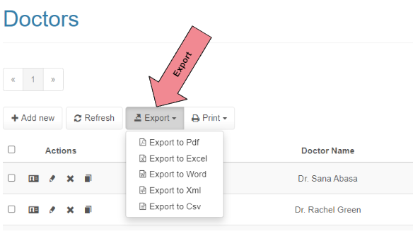

1. Is there a way to sort the table by a specific column, such as ascending or descending?

* Yes, there is a button that looks like this( ) when you click on this button you can choose one column or even multiple columns to sort the table based on. And you are able to choose whether you prefer to sort it in a ascending or descending order.

Once you click on the button you will have the following small table that will appear at the top:

You can press on add level then choose the column and the way you wanted to be sorted:

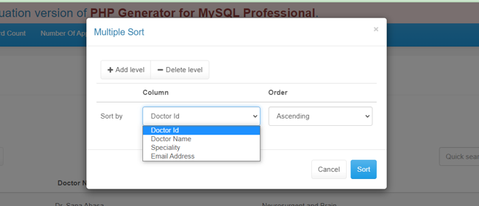

1. Can I view any data related to the appointments or medical records for a specific patient.

* No, you do not have the permission to access the appointments or medical record tables overall, or even perform any operations to access it.
  1. Contact Information:

If you need any farther help with your functionalities in the database, or if you have problems, questions or even feedbacks, feel free reach me at any time using the following contact details:

Email : [21110294@htu.edu.jo](mailto:21110294@htu.edu.jo)

Phone: 0797174232

Office address: HTU university at the Business Park, new buildings, fourth floor office Y-23. Available at my office from (Sunday to Thursday) from (8 AM to 6 PM).